ASSIGNMENT: 6

- Draw and label a simple home network diagram showing a router, switch, and three devices (like a laptop, smartphone, and smart TV), indicating how each device connects to the network.
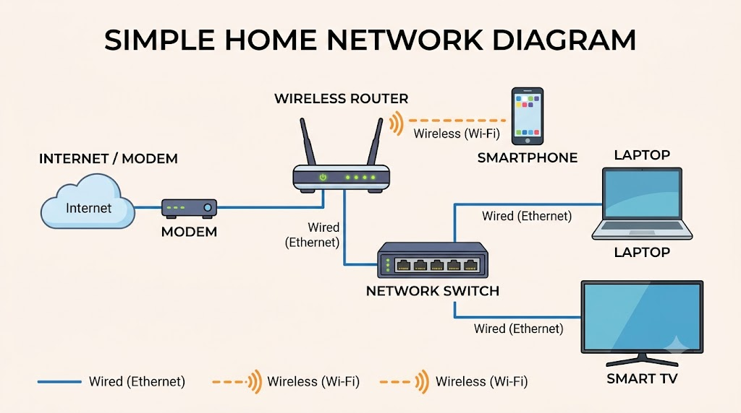

- Create a comparison table listing at least four network devices (router, switch, hub, access point) and describe one real-world use case for each, referencing apps or services you use daily (e.g., WiFi for streaming on YouTube, LAN gaming, etc.).

Network Devices and Their Uses
Device | What It Does | Real-World Use Case
Router | Connects networks and routes data between them. | Home Wi-Fi for YouTube: Connects your home network to the internet so you can stream YouTube on your phone.
Switch | Connects multiple devices within the same LAN using MAC addresses. | College Computer Lab: Connects lab computers so students can access shared files and printers.
Hub | Broadcasts incoming data to all connected ports. | Old LAN Gaming Setup: Previously used to connect computers for multiplayer gaming; rarely used today.
Access Point | Provides wireless connectivity to a wired network. | Office/Café Wi-Fi: Allows customers and staff to connect their phones and laptops wirelessly.

- Write a short scenario where you explain how data travels from your phone to the internet when you order food on Zomato, mentioning the role of each network device involved (router, switch, access point).

Scenario
When you open Zomato on your phone and tap "Place Order," your order data travels from your phone to Zomato's server through multiple network devices. Each device plays a specific role in moving the data.
Role of Each Device
1. Access Point
Your phone connects to the WiFi network through an access point. The access point receives the radio signals (data) from your phone and converts them into wired signals for the network. It acts as the bridge between your wireless phone and the wired network.
2. Switch
The switch receives the data from the access point. It reads the MAC address and forwards the data to the correct port that leads toward the router. The switch works within the local network (LAN) and ensures data reaches the right destination.
3. Router
The router receives the data from the switch. It reads the IP address and routes the data to the internet through your ISP. The router connects your home network to the outside world and finds the best path to Zomato's server.
4. Internet (ISP & Servers)
The data travels through the internet, passing through multiple routers at the ISP and beyond, until it reaches Zomato's server. The server processes your order.
5. Return Path
Zomato's server sends the confirmation back through the internet, then to your router, then to the switch, then to the access point, and finally wirelessly to your phone.

- Given this situation: you have a WiFi router, but your gaming PC only has an Ethernet port and is far from the router. Suggest two different network devices you could use to connect your PC to the internet and explain how each would work in this setup.<br><br><em><strong>Hint:</strong> Think about devices like switches, powerline adapters, or WiFi extenders.</em>

Two Suggested Devices for Wired Internet Connection
Device | How It Works
Wi-Fi Extender (with Ethernet Port) | Connects wirelessly to your router and provides an Ethernet port. You connect your PC to this port using an Ethernet cable, allowing the PC to access the network.
Powerline Adapter | One adapter connects to the router using an Ethernet cable, while another plugs into a wall socket near your PC. Network data travels through your home's electrical wiring, and an Ethernet cable connects the second adapter to your PC.

